
DATES FOR YOUR DIARY

Saturday, June 27th at 7 p.m.
Stonedge Gospel Singers

Speaker; Pastor Phil Waters of
Holmgate Evangelical Church, Clay Cross

Buffet Supper to follow Service
------------------------------------
Worship at Birches Lane Church in July
First Sunday – 10.30 a.m. & 6 p.m. other Sundays at 6 p.m.

Preachers;
July 5th - 10.30 a.m. Family Service led by Ray & Beryl Briddon
and Rachel Hodges
6.00 p.m. Paul White
July 12th - 6.00 p.m. Andrew Lamb
(includes the Lord’s Supper)
July 19th - 6.00 p.m. Flowers in Memory Service
(Leader; Helen Curzon)
July 26th - 6.00 p.m. Simon Brewer

CONTACT INFORMATION
Website www.bircheslanechurch.co.uk
Email greenlander7@outlook.com
Telephone 07790 352691 (Derek)

ALL ARE WELCOME

DE55 7LZ
“IN TOUCH” – NEWSLETTER
JULY – 2026

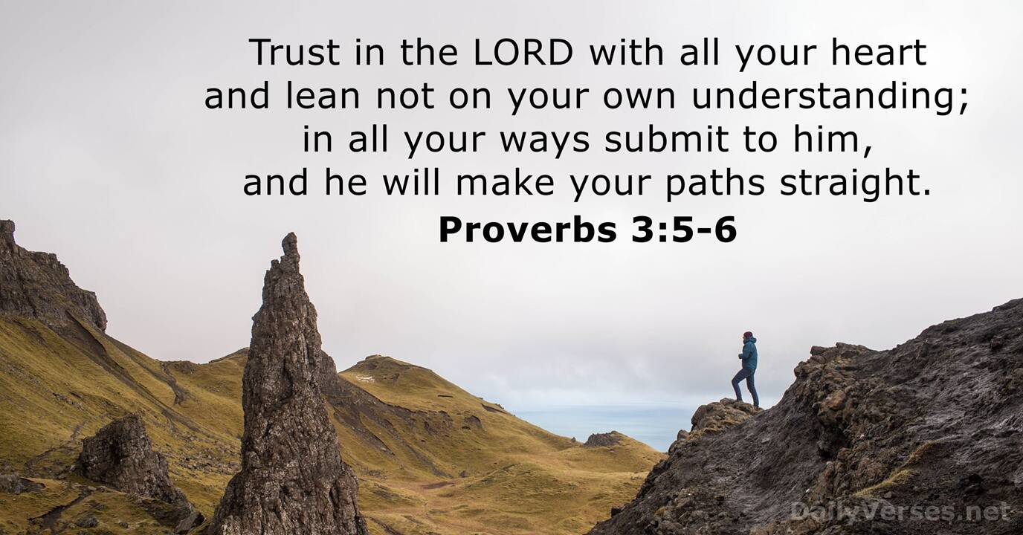

Worship for all the Family
Sunday 5th July at 10.30 a.m.
Join us for Family worship at Birches Lane


Ray & Beryl Briddon and Rachel Hodges will lead our Family Service on the first Sunday morning in July. This Service is for Children and their Mums, Dads, Grandmas and Grandads, - for everyone!
……………….


Coffee & Cakes Morning!

Saturday July 18th
10 a.m. till 12 noon

Come and enjoy free coffee
and cakes!

ALL ARE WELCOME!
……………….

Prayer Meeting and Devotion.
Wednesday evenings July 8th, and July 22nd
join us at 7 p.m. for Prayer.
……………….



Wednesday evenings July 1st, 15th and 29th.
Exploring the Bible at BLC starts 7 p.m.
………………

Scripture reading for July –
Proverbs Chapter 3 verses 5 and 6
“NIV Bible”
“Trust in the LORD with ALL YOUR HEART and lean
not on your own understanding;
in ALL your ways submit to him,
and he will make your paths straight”

