
DATES FOR YOUR DIARY

Saturday, June 27th at 7 p.m.
Stonedge Gospel Singers

Speaker; Pastor Phil Waters of
Holmgate Evangelical Church, Clay Cross

Buffet Supper to follow Service
------------------------------------
Worship at Birches Lane Church in June
First Sunday – 10.30 a.m. & 6 p.m. other Sundays at 6 p.m.

Preachers;
June 7th - 10.30 a.m. Family Service led by Derek Lander
and Rachel Hodges
6.00 p.m. Ross Paradise
(includes the Lord’s Supper)
June 14th - 6.00 p.m. Ray Briddon
June 21st - 6.00 p.m. John Hill
June 28th - 6.00 p.m. Chris Cole

CONTACT INFORMATION
Website www.bircheslanechurch.co.uk
Email greenlander7@outlook.com
Telephone 07790 352691 (Derek)

ALL ARE WELCOME

DE55 7LZ
“IN TOUCH” – NEWSLETTER
JUNE – 2026

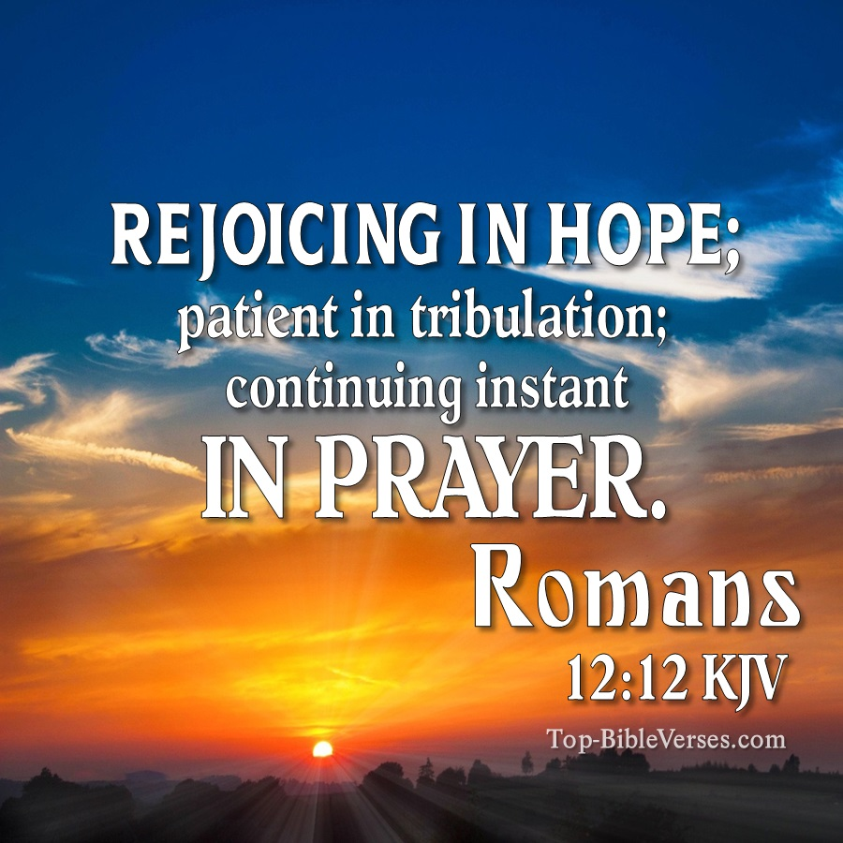

Worship for all the Family
Sunday 7th June at 10.30 a.m.
Join us for Family worship at Birches Lane


Derek Lander and Rachel Hodges will lead our Family Service on
the first Sunday morning in June. This Service is for Children and their Mums, Dads, Grandmas and Grandads, - for everyone!
………………………


Coffee & Cakes Morning!

Saturday June 20th
10 a.m. till 12 noon

Come and enjoy free coffee
and cakes!

ALL ARE WELCOME!

Prayer Meeting and Devotion.
Wednesday evenings June 10th, and June 24th
join us at 7 p.m. for Prayer.
……………………………………….

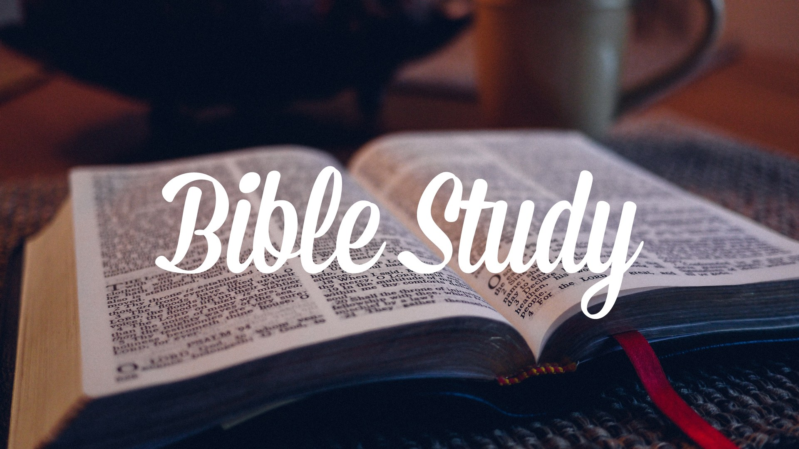

Wednesday evenings June 3rd, and June 17th.
Exploring the Bible at BLC starts 7 p.m.
……………………………

Scripture reading for May / June –
Romans Chapter 12 verse 12 –
“NIV Bible”
“Rejoicing in hope; patient in tribulation;
Continuing instant in prayer.”

