Worship at Birches Lane Church in April
First Sunday – 10.30 a.m. & 6 p.m. other Sundays at 6 p.m.

Preachers in April:
April 5th 10.30 Family Service led by Pastor Ben Lamb
6.00 Derek Lander (includes the Lord’s Supper)
April 12th Scott Armstrong
April 19th Ray Briddon
April 26th Pastor Phil Waters

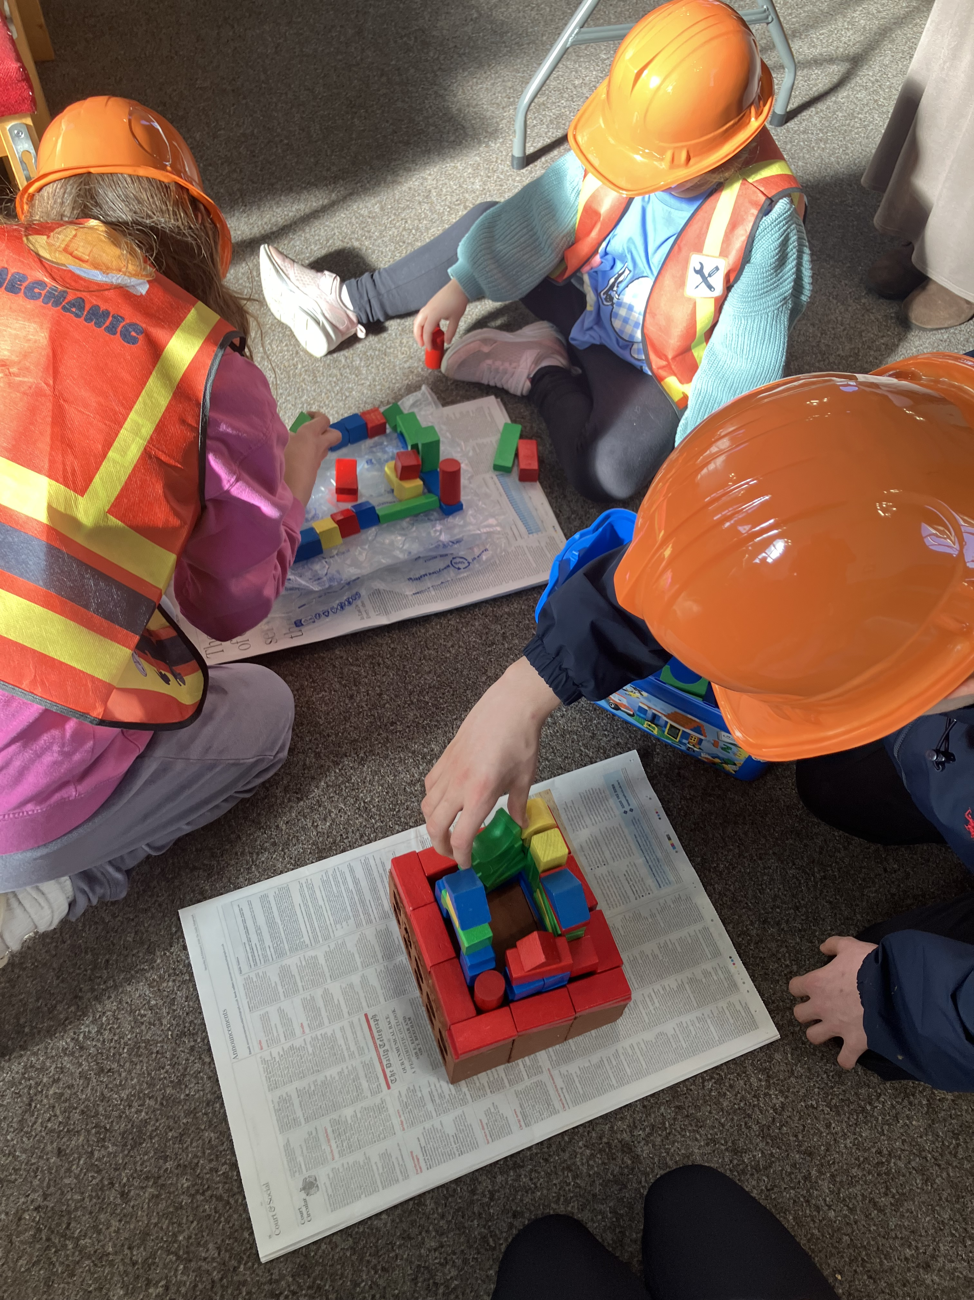
At our March Family Service, we learned about the parable of the two builders
(see Matthew chapter 7 verses 24-27 and Luke chapter 6 verses 46-49).
Pictured are some of the children engaged in construction of two “houses”!

CONTACT INFORMATION
Website www.bircheslanechurch.co.uk
Email greenlander7@outlook.com
Telephone 07790 352691 (Derek)



DE55 7LZ
“IN TOUCH” – NEWSLETTER
APRIL – EASTER 2026

Worship for all the Family
Sunday 5th April at 10.30 a.m.
Join us for Family worship at Birches Lane!


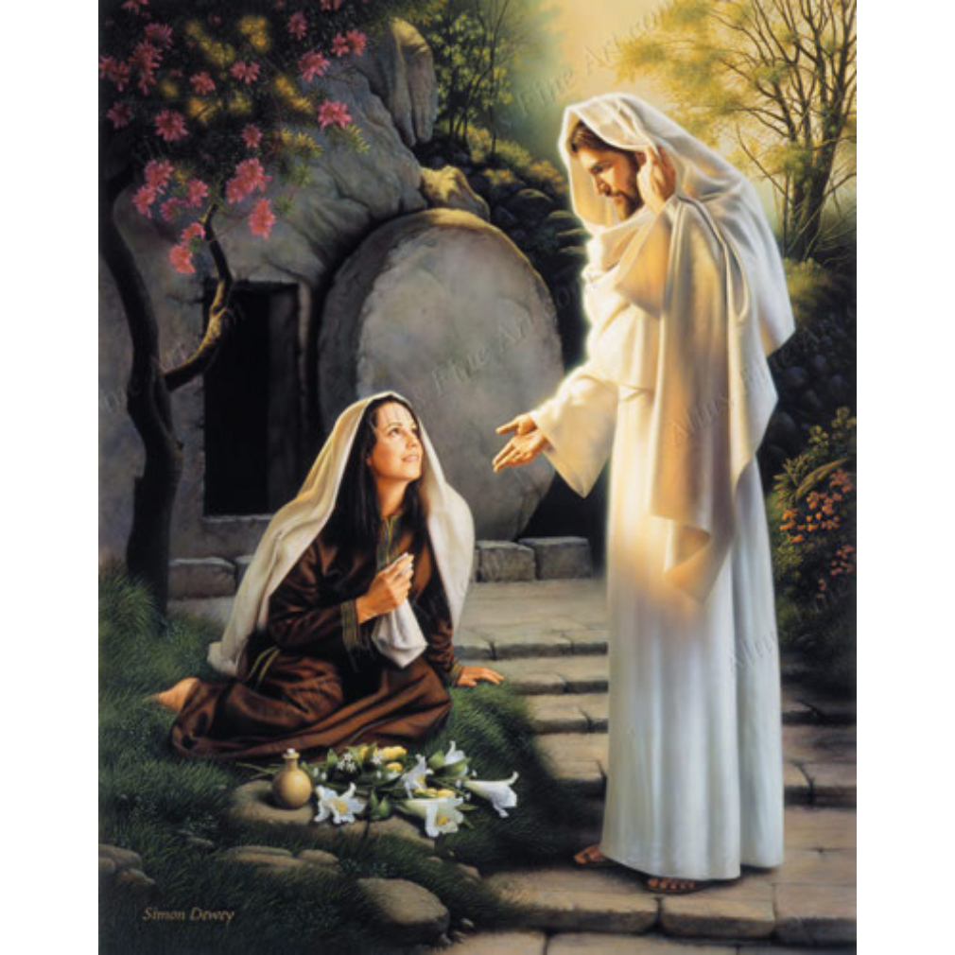
Pastor Ben Lamb and Rachel Hodges will lead a worship service for children and their families as we celebrate Easter- Jesus rising from the dead! There will be refreshments afterwards. Come and join us as we celebrate the new life of Jesus!

Easter at BLC
Good Friday – April 3rd
2 p.m. United service at All Saints Church Hall, Church Lane, South Wingfield

Easter Sunday – April 5th

10.30 a.m. Family Service

6.00 p.m. The Lord’s Supper

“Woman, why are you weeping?” (John chapter 20 verse 15)


Coffee & Cakes Morning!

Saturday April 18th

10 a.m. till 12 noon

Come and enjoy!


Wednesday evenings April 1st, 15th and 29th
Exploring the Bible at BLC starts 7 p.m.

Prayer Meetings
Wednesday evenings April 8th and 22nd
- join us at 7 p.m. for Prayer

