
Wednesdays 4th and 18th at 2 p.m. at the Church.
Come and join us as we explore the Book of the Acts of the Apostles


Saturday 14th March 6 p.m. for 6.30 p.m. Buffet Supper and Quiz. Anyone wishing to attend MUST book by contacting Derek on 07790 352691.


There will NOT be a Coffee Morning in March but will continue again on Saturday the 18th April at 10 a.m.



DE55 7LZ

“In Touch” Newsletter - March 2026
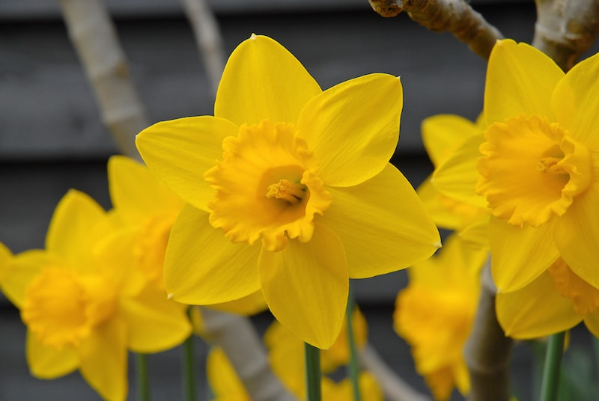

Worship for all the Family
Sunday 1st March at 10.30 a.m.
Join us for Family worship at Birches Lane!


This simple service will particularly be focussed on families with children and those for whom church might be a new experience!

Michael Tinker’s Family Show
Join us for a fun filled afternoon for all the family!
Saturday March 21st starts at 2 p.m.
Doors open at 1.30 p.m. Refreshments afterwards

Advance Notice.
On Good Friday, April 3rd, at 2 p.m. a United Easter Service will be held at the newly refurbished All Saints Church Hall. All are very welcome to attend this special event.

Worship at Birches Lane Church in March
First Sunday – 10.30 a.m. & 6 p.m. other Sundays at 6 p.m.

Preachers in March:
March 1st 10.30 ---- Family Service
6.00 Derek Lander (includes the Lord’s Supper)
March 8th Nick Fletcher
March 15th Paul White
March 22nd George Clayson
March 29th Chris Cole

The Beatitudes
‘Blessed are the peacemakers, for they shall be called sons of God’ - Matthew chapter 5 verse 9

To be a Christian is to have been reconciled with God through Jesus Christ. This is the good news (gospel) of Jesus- ‘good news of peace through Jesus Christ’ (Acts 10: 36). Once God’s enemy, the Christian has been reconciled. And that is part of the calling of every Christian- to make peace with other people and to share Christ’s peace with them, pointing them to the only one in whom they may find peace. To restless hearts, to those aware of their distance from God to those in conflict situations, the message of the gospel is that you can find peace through Jesus Christ, and Christians are peacemakers when they demonstrate this by their words and their actions.

Contact Information
Website- www.bircheslanechurch.co.uk
Email greenlander7@outlook.co
Telephone 07790 352691 (Derek)

